# Guideline

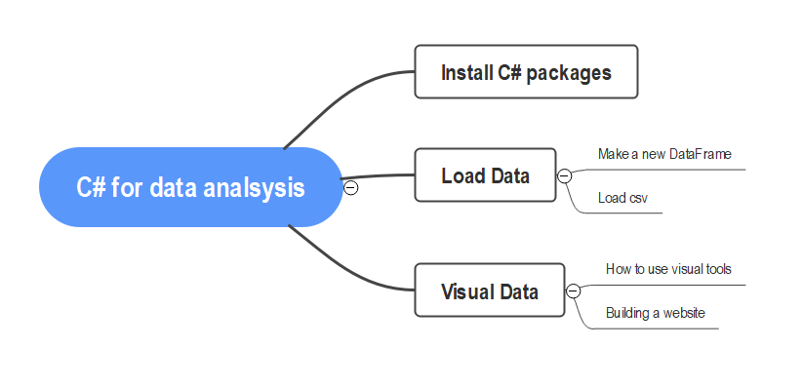

# Install and use the package tools

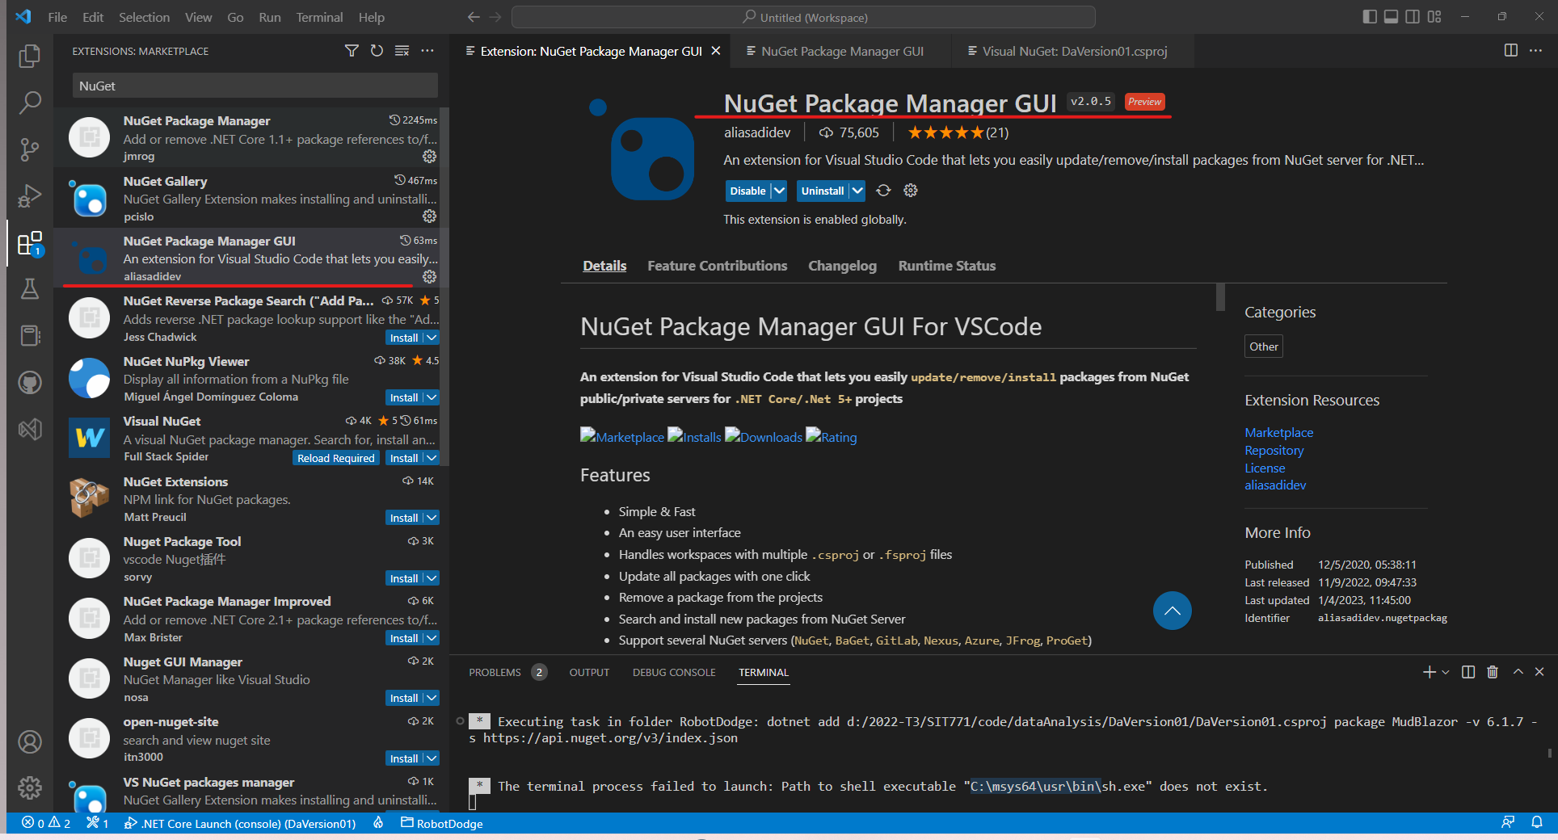

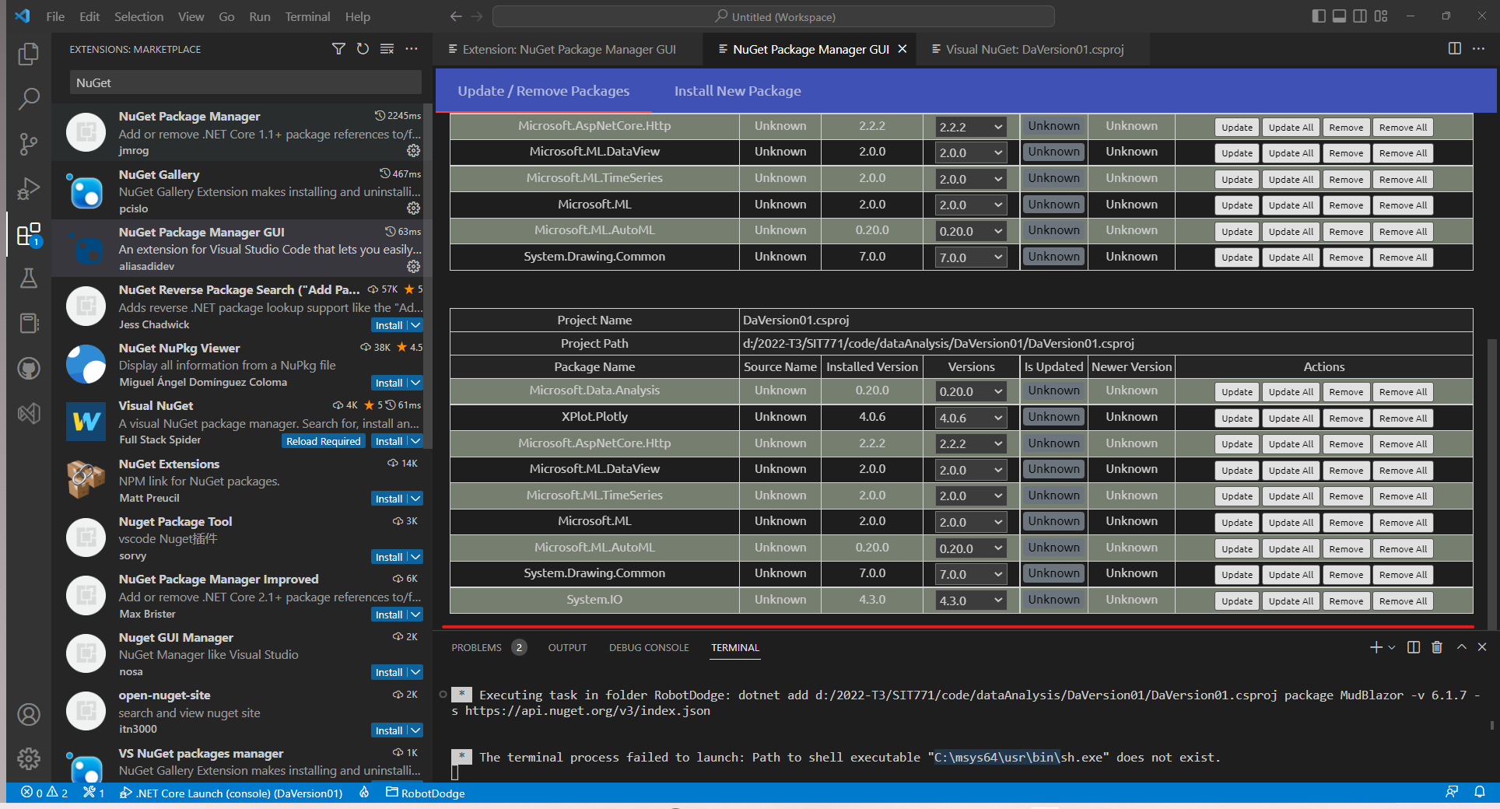

Ctrl + shift +P

# Package for this topic:

// HTTP Listener + WebPage

using System;

using System.Net;

using System.IO;

using System.Text;

using System.Threading.Tasks;

// Data Analysis

using Microsoft.ML;

using Microsoft.Data.Analysis;

using Microsoft.ML.Data;

// Visual chart

using XPlot.Plotly;

// Reference static method

using static DataAnalysis.Visual;

using static DataAnalysis.Website;

using static DataAnalysis.TrainModel;